Achieving a Healthy America Via An Ideal Health System
[Via An Ideal Person-Centered, Affordable, Accessible, Quality Community Health System]

There is much useful and thought provoking discussion of the future of health reform in the light of the Affordable Care Act. Regardless of one’s view on the wisdom and design of the ACA, there is consensus that it was not necessarily or even probably going to achieve a healthy America. The key precursors - affordability, quality and accessibility - may be improved, but not enough. Special concerns are expressed about affordability and its not being sufficiently addressed.

Today in America, we are spending 1/6th of our national economy on health without producing healthy Americans or a healthy America. Most of the rest of the world faces major challenges in achieving healthy people and healthy nations. Without a large change in health vision, strategy and execution, our future will be as disappointing as our past.

We still do not have and are not on the track to achieve the American health system we need. While much good work has been done on the issue of a high performance health system by organizations like the Commonwealth Fund, there is still not a clear idea of what should be the American health system that will achieve a healthy America.

This piece is a humble attempt to suggest such a health system. The characteristics of an ideal American system are suggested. The design of an ideal health system is suggested as it might apply to a “community”, whether that is at the local, regional, State, national or global level. Key is to have a system that is desirable to the American people, ensures affordability, quality and accessibility, and achieves a healthy America and healthy Americans. And, possibly, it might prove useful to other nations struggling to achieve their own healthy nation and healthy people.

Characteristics of an Ideal “Community” Health System
An ideal “community” health system is a “health” system, not a “health care” or “medical care” system that are key parts of a health system. An ideal health system is person-centered, affordable, accessible, quality, virtual, integrated and community-focused. It is “virtual” in that not all the elements are owned or managed by any one single organization, not all the elements are in one location, and not all the health care providers and support are physically or organizationally connected. It is a virtual, integrated health system in that all the elements are connected functionally, including to the person, to support a person’s and community’s health. It is a “community” health system in that it supports the health of the person as an individual and the health of the community (whether local, regional, State, national and/or global) of which the person is a part.

An ideal system has the following key characteristics in terms of the person, a “virtual” integrated system, performance, and private and public sector supportive actions and interventions:

Person
- Person health and function - The ideal system understands a person’s health and function from the person’s perspective and understands and does what it takes to maintain and improve health and function. Ideally, a person spends her/his whole life where “I am healthy & function well.” But for most every person will need a high performance health system during her/his life as it includes many different health situations:
  - I’m healthy and I stay healthy or become very healthy.
  - I’m functioning well and I continue to function well or function even better.
  - I’m ill and/or not functioning well and I get better.
  - I risk getting worse and I don’t get worse.
  - I’m chronically ill and I successfully manage.
  - I have a disability and I successfully cope.
  - I’m near end of life and I successfully cope.
- Motivation and Ability - The ideal system and its people understand how a person’s motivation and ability affects her/his behavior as it relates to health. But it is more than just the person’s motivation and ability; it is also her/his providers’ motivation and ability. One of the substantial weaknesses in today’s health care is the lack of skills and knowledge with respect to human motivation and ability and how it relates to improving health related behavior. This lack exists even though most of the knowledge exists and it continues to improve. Providers must partner with a person on motivation and ability that positively affect key behaviors that improve health and avoid harming health.
- Financial resources - The ideal system recognizes that another aspect of ability is that each person has a different ability to pay based on their financial resources and health insurance coverage and ensures that a lower ability to pay does not prevent a person from receiving needed health care and support.
- Behavior - As with motivation and ability, the ideal system and its people understand how a person’s behavior affects health and works successfully with the person and her/his family and providers to improve health. The person’s behavior affecting health includes general lifestyle, efforts to reduce risk factors (including obesity, tobacco use, alcohol and drug misuse), rehabilitation, and adhering to care requirements (including taking needed medications; following post-surgical follow-through). But it is more than just the person’s behavior; it is also her/his providers’ behavior. One of the substantial weaknesses in today’s health care is the lack of skills and knowledge with respect to human behavior and how it relates to improving health. This lack exists even though most of the knowledge exists and it continues to improve. Providers must partner with a person on the key behaviors that improve health and avoid harming health.
- History, genetics and environment - To positively affect health, the system’s people understand the person’s genetics and health-related history and environment and how to work with them. Providers must partner with a person to incorporate history, environment and genetic factors into any strategy that improves health and avoids further harming health.
- Family and community support -The system and its people understand the key role that family and community support can play in avoiding things that harm health and providing support that improves health. Support can be psychological when a person is sick or has a disability or a person is trying to improve on a health-related behavior. Support can be physical when a person needs reminding on taking a medication, needs to get to a health care provider, or needs care for a condition which limits the ability to think, move or do basic functions like food preparation or personal hygiene. Support can be provided by family members, friends, neighbors, community volunteers, and private and public sector community organizations.

“Virtual” integrated system
- Person-centered - The ideal health system is “person-centered”, meaning that all efforts of the system are centered on the individual person (of which there are over 300 million in America) and their staying healthy, getting better, living with illness or disability, and coping with the end of life. Each person is different to some greater or lesser degree. She/he can differ in genetics, environment, occupation, family and community support, attitude toward and knowledge of health and health care, ability (including physical ability and knowledge/skills), and motivation (though each person has the need to survive and desire to thrive). Centering the system on the person and making any health intervention match the individual person helps the system help the person achieve better health and functioning.
- Partnership among person and providers - Within the “health care” part of the health system, the “partnership” between the person and her/his providers and payers is key. Ideally, a person spends her/his whole life where “I am healthy & function well.” But for most every person, life includes many different health situations where a partner is important:
  - I’m healthy and, together with you, I stay healthy or become very healthy.
  - I’m functioning well and, together with you, I continue to function well or function even better.
  - I’m ill and/or not functioning well and, together with you, I get better.
  - I risk getting worse and, together with you, I don’t get worse.
  - I’m chronically ill and, together with you, I successfully manage.
  - I have a disability and, together with you, I successfully cope.
  - I’m near end of life and, together with you, I successfully cope.
- Health home - Within the health system, a partnership between the person and her/his creates a mutually agreeable “health home” that provides a trustworthy, comfortable provider and place, provides or facilitates a person-accessible repository (actual or virtual) for all of the person’s health information (including the complete health record), and works to monitor and improve the whole health of the whole person across all settings and across all preventive, primary and specialty care.
- Coordinated care across settings and across primary care, prevention and specialty care - Lead by the person and her/his primary care provider, care across all settings and across prevention, primary care and specialty care is fully coordinated to help achieve the best use of resources and achieve the best outcomes and health and functional status.
- Comprehensive services - The health system includes the full range of services needed for prevention, for rehabilitation, and for diagnosis and treatment by primary care and all needed specialties and in all needed settings. In the case of rural or small communities, this may require partnering with other communities in order to make comprehensive services available and to help ensure reasonable accessibility, including travel.
- Care in the community - Recognizing the value of care in health care organizations and their facilities (hospitals, physician offices, nursing homes), much of health’s future interventions occurs outside health care facilities and in the community. Health care organizations provide some of that care, for example via telehealth. Other organizations provide some health support, for example promoting positive health behaviors and/or reducing risk factors like obesity, tobacco use and alcohol and drug misuses). Family and the community provide some support similar to what has been done since before there was formal health care. The person does self-care from prevention to treating minor illnesses and injuries to rehabilitation.
- Population and public health - The health system fully incorporates the community’s public health agency support at all appropriate levels (including local, State, Federal). The public health agency provides leadership and core services and resources for overall population health for the community. Working collaboratively with the private sector and other public health agencies, the community’s public health agency also serves as the lead and coordinator for the community’s population health. Other private and public organizations which have responsibility for a segment of the community’s population and their health effectively carries out that responsibility.
- Insured - The system ensures that achieving good health for the person and the community is affordable for all payers - self, employer, private insurance, and public insurance (including Medicare, Medicaid, CHIP, CHC, Other) funded by taxpayers. To help ensure affordability for the person and to avoid health-related financial catastrophes, affordable health insurance (public and/or private) is needed that reflects a person’s ability to pay premiums, coinsurance and non-covered health care costs.
- All payer, affordable, fair, value-based payment - Payment is the same for all payers (private insurance, public programs (including Medicare and Medicaid), employer self-funded plans, and individual persons) for the same service. Payment rates should be fair in that they pay what it appropriately costs to provide a high quality service. Payment is based on value provided whether for an episode of care or per capita for a year of care. For people who are Medicare eligible, Medicare payment rates are used. For people who are not Medicare eligible (including self-pay and Medicaid), best practices private insurance payment rates are used.
- e-enabled - Each person and the providers who care for her/him are fully enabled with electronic systems. Such systems include electronic health records (with decision support) and personal health systems (access to EHRs, personal health data, education, support, communication with providers). They follow standards for content, decision support and exchange. They facilitate accurate, complete, secure and private exchange of personal health information among each person and any providers who care for him/her at any time in any place.
- Partnership among private and public sector - The ideal system is dependent on both the private and public sectors partnering in order to create, operate and sustain a system that is used effectively by every person, uses valuable resources effectively and efficiently, and achieves the highest health and functional status possible for every person. Private and public sector health care organizations partnering with public health agencies is essential to providing the full range of services (prevention, primary care, specialty care, inpatient care, nursing home and home care, rehabilitative care) in the full range of settings, including in the community.

Performance
- Good person health - As indicated earlier, the ideal system understands a person’s health and function from the person’s perspective and understands and does what it takes to help maintain and improve health and function. Ideally, the person and the supportive system together increase the chances that a person spends most of her/his life where “I am healthy & function well.” The system’s performance is measured by each person’s health and functional status throughout her/his life.
- Good community health - The ideal system understands a community overall health and functional status the people’s perspective and understands and does what it takes to help maintain and improve health and function for all the people in the community. Ideally, the person and the supportive system together increase the chances that the whole community spends most of their lives where everyone can say “I am healthy & function well.” The system’s performance is measured by each and every person’s health and functional status throughout their lives. Further, the community’s people and their lifestyles, their work, and their environment (home, neighborhood, work, education, recreation) do minimal harm to health and help improve health and function.
- Affordable - The ideal system is affordable for every person and every payer - self, employer, private insurance, and public insurance (including Medicare, Medicaid, CHIP, CHC, Other) funded by taxpayers. It ensures that every person gets needed health care and support without negatively affecting essential food, shelter, transportation, education and other basic necessities of living. The person is responsible for using the health system prudently so as to not waste valuable health resources and is responsible for taking all reasonable steps to live a healthy lifestyle and to partner with her/his health care provider so as to increase the likelihood that a health problem is successfully diagnosed and treated (including rehabilitation from injury or illness and treatment of injuries and acute and chronic illness).
- Accessible - The ideal system is accessible, not just in terms of affordability, but in terms of all aspects of accessibility. This includes physical proximity, physical access into a health care facility (including accessibility and usability for people with disabilities), reasonable hours for non-urgent care, transportation for regular and urgent care, transportation for emergency care, non-discrimination for any reason, and reasonable accommodation for special needs (including language, cognitive limitations, cultural needs).
- High quality - The ideal system provides high quality services and produces good outcomes reflecting the best knowledge available on how best to prevent and treat health problems and maintain and improve function.
- Safe - The ideal system provides as safe an environment as possible in which to receive health care and support. This includes successfully minimizing misdiagnosis, inadequate or wrong care, negative drug-drug interaction, and illnesses acquired while at a health care facility.
- Minimal inconvenience - The ideal system minimizes inconvenience for the person needing health care and support. Having to spend too much time in waiting rooms or having trouble getting into care (for example, getting an appointment) can be a major inconvenience, especially a sick or injured person. When a person is sick or worried, time between visits and tests can be inconvenient, especially when the time span is days or weeks. In rural and some urban areas, travel time and distance can be inconvenient. The ideal system minimizes inconvenience to as close to zero as is human possible.
- Privacy protected - The ideal system protects the privacy of health care and information, especially particularly sensitive information such as sexually transmitted diseases, drug and alcohol abuse/misuse, and mental illness. Health information becoming public can be embarrassing, compromise trust, increase insurance rates or prevent insurability, threaten or prevent employment.

Private and public sector supportive actions and interventions
For a person and the community, there are actions that improve health or make it worse. In a systematic and coordinated manner, the ideal health system improves health status by helping support actions that increase health and helping stop actions that decrease health. People (including the person and his/her providers and other parts of the private and public sectors) who are part of the system do interventions that best a) achieve the highest levels of health, b) prevent more poor health, and c) move people up from poor health. To improve health most, we need to execute a "systematic strategy" – a “system” of actions that continuously stops actions that push people down to less healthy states and supports actions that lift people out of poor health and toward being healthy. This “system” of actions, when well designed and executed, can perpetually prevent much poor health and support people moving up from poor health to being healthy. [See Figure 1. Achieving a Healthy and Thriving Future]

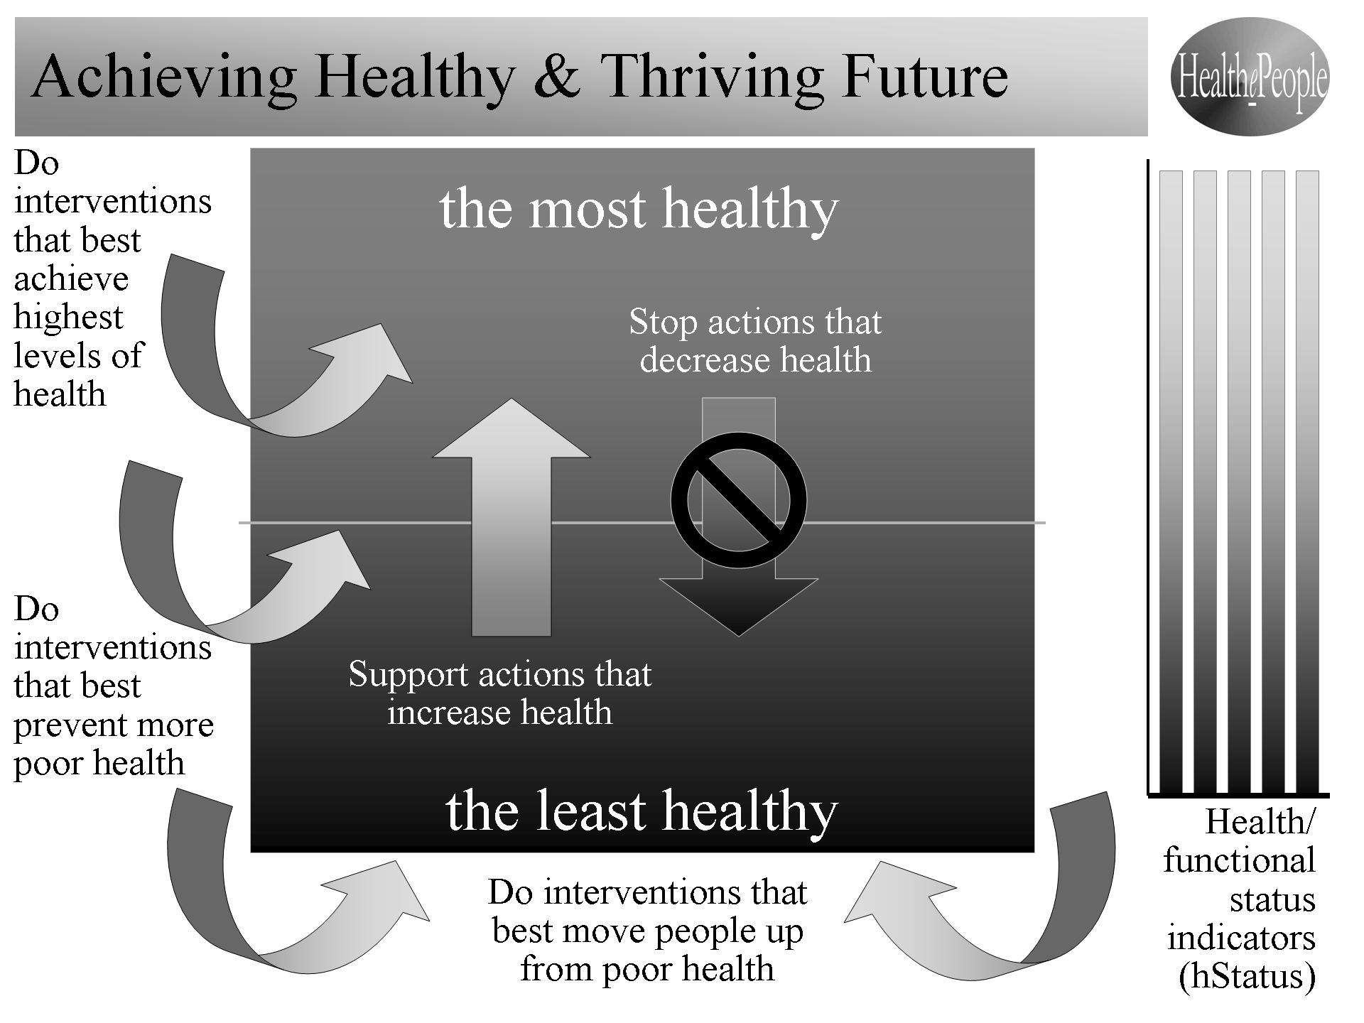
Figure 1. Achieving a Healthy and Thriving Future.

The overall strategy is built upon a strategic improvement and behavior model for health. We need to set the target health and functional status we are trying to achieve under the vision “healthier/healthy Americans”. Given the target status, we can decide on the target outcomes needed and on the target health system needed to achieve those outcomes. Comparing the optimized outcomes and health system with the current health system and its performance, we can determine the “delta”, i.e., the needed improvements in the current health system and its outcomes to achieve the ideal health system and its much better outcomes.

Knowing what needs to be improved, we can then determine what personal and health provider behaviors should change. Human behavior, both by a person and her/his health providers, is key to making and sustaining the improvements. Existing behavioral models helps us think through how we bring about the behavior change necessary to make the improvements. Together, the system and behavior changes are intended to produce improved health and functional status for all.

Design and Operation of an Ideal “Community” Health System

So what is an ideal “community” health system’s design and how does it operate? An ideal health system is designed to be person-centered, affordable, accessible, quality, virtual, integrated and community-focused. It is a “virtual health system” for the purpose of achieving the highest level of personal and community health and function by integrating the health care and support of many supportive organizations and services working together under both formal and informal relationships. [See Figure 2. An Ideal Person-Centered, Affordable, Accessible, Quality, Virtual, Integrated, Community Health System]

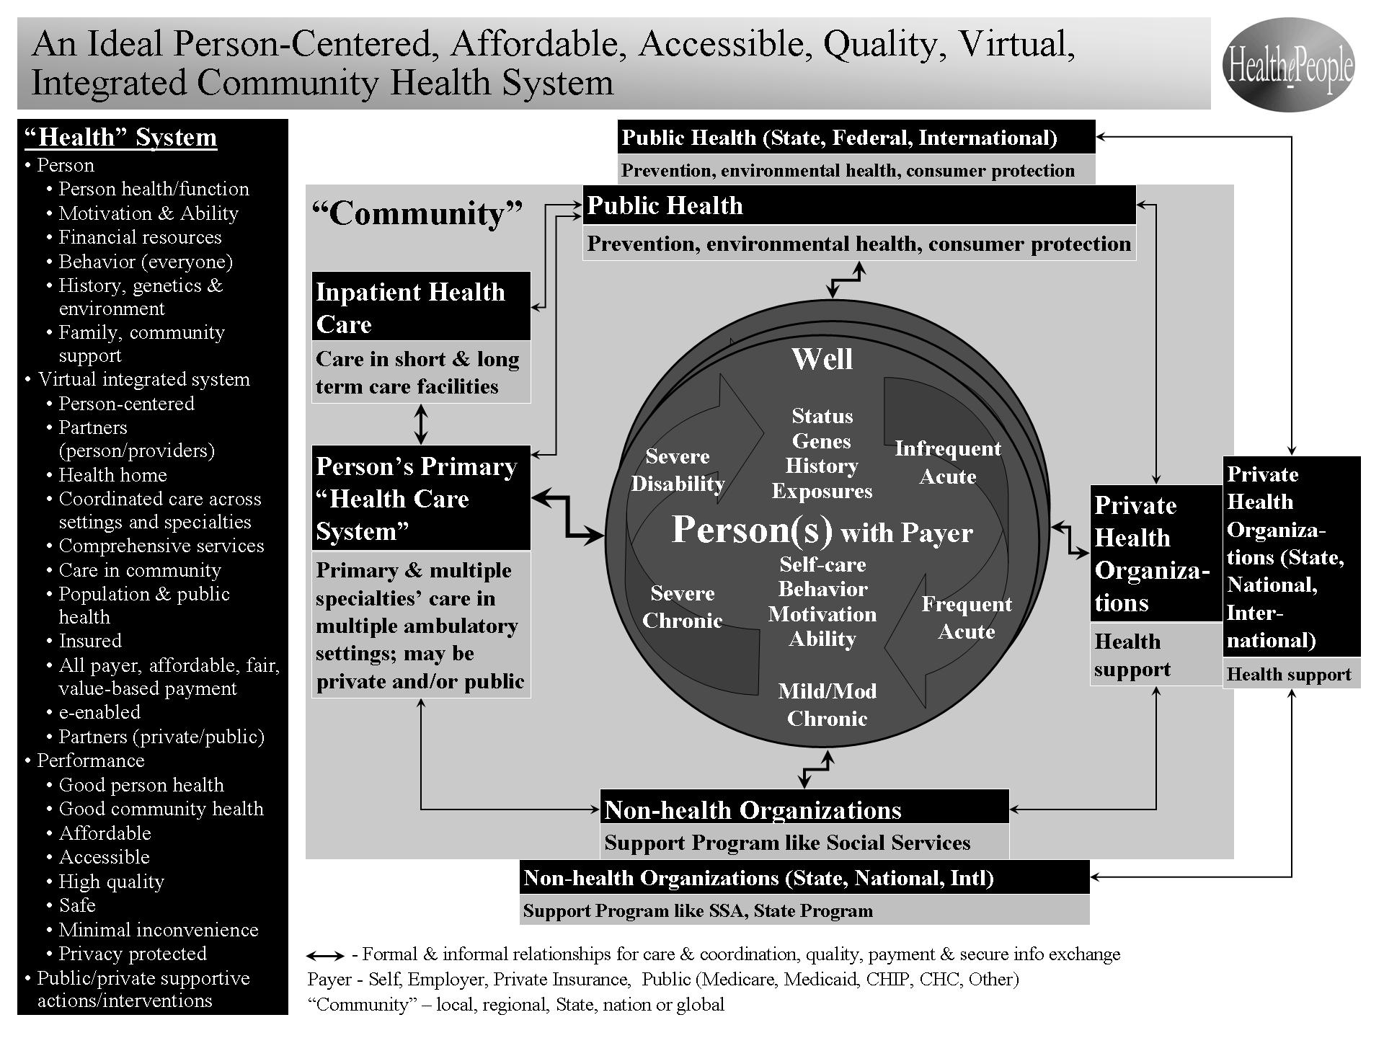
Figure 2. An Ideal Person-Centered, Affordable, Accessible, Quality, Virtual, Integrated, Community Health System.

For most communities, the health system consists of the following elements engaged in the related behaviors:

- Person partnering with her/his Payer (Self, Employer, Private Insurance, Public (Medicare, Medicaid, CHIP, CHC, Other))
  - Behavior, Self-care, “Community” Support
- Person’s Primary “Health Care System”
  - Primary & multiple specialties’ care in multiple ambulatory settings; may be private and/or public
- Inpatient Health Care
  - Care in short & long term care facilities
- Public Health at the local level partnering with Public Health at the State and Federal levels.
  - Prevention, environmental health, consumer protection
- Private Health Organizations at the local level which may also be partnering with Private Health Organizations at the State and national levels.
  - Health support
- Non-health Organization at the local level which may also be partnering with Non-health Organizations at the State and national levels.
  - Support Program like Social Service, Social Security Administration, State programs

The ideal health system has the person and the community as its center. Everything it does and achieves is centered on them.

The health system understands and accepts that the person and the community are focused on their (and the people they care about) need to survive and desire to thrive. Most people and most communities do not have health care as their primary interest. Most people just want to live and enjoy their lives. Health care is something the person needs as a means to remove or minimize any health or function problems that get in the way of living and enjoying her/his life.

The health system understands and accepts that, in general, a person, a community, a State and a nation are better off (health, best use of resources) to the extent to which each and every person stays as healthy and highly functional as possible and uses the health system only when there is an unavoidable injury, illness or disability.

The health system understands and successfully addresses the full range of a person’s health - being well and/or having infrequent acute illness, frequent acute illness, mild/moderate chronic illness, severe chronic illness, and severe disability. At any given time, a person may be well. Or a person may be somewhat well but may be dealing with a disability or managing a non-severe chronic disease. Or a person may not be well and experiencing multiple health problems - a disability, a chronic disease, an injury and/or an acute illness.

The health system understands and successfully addresses that, over time from before birth until death, a person’s personal status and health and functional status may change many times. The needs of the mother and infant are different than that of an older child than that of a young adult than that of a middle-aged adult than that of an older adult. Over time, the health and functional issues are often different but not necessarily so. Severe disability can occur at any age and can span a little or much of a person’s life.

In a community, all combinations of personal status and health and functional status may exist at any time and over time and at any phase of life. They need to be successfully addressed by the health system.

As detailed earlier, the ideal health system understands and helps achieve affordability, quality, accessibility and high levels of health and functional status for the person. It understands and helps achieve affordability for the person’s payer. This is essential whether the payer is the person her or himself, an employer, private insurance, and/or public insurance (including Medicare, Medicaid, CHIP, Community Health Centers, locally and publicly financed clinics and hospitals). Prices and price increases are kept as low as possible without compromising quality. Only needed care is provided. Care is consistent with generally accepted practice and best available evidence. Care is provided in the most effective and efficient manner consistent with producing the best outcomes and health and functional status.

How does the ideal health system operate? In many ways, it is the mostly informal health system that we have in America today but it performs at a much higher level. The relationships among providers continue but are more person-centered, are more integrated, are more effective and efficient, and better share a person’s care-related information.

Starting at the beginning of a person’s life, a formal partnership begins with a primary health provider (e.g. a pediatrician). There are already formal partnerships with the other family members. These partnerships not only address the individual family member but do so in the context of the whole family. The family may have a “family” partnership with a family practice provider. As a person progresses through life, the person’s health provider partner changes, including from a pediatrician for children to a physician for adults. That change is done seamlessly as the person chooses a new health provider, health records are transferred, and the two providers collaboratively transition the person’s care. The same may happen later in life if a person chooses to partner with a geriatrician. During a person, a person may change health provides and the same seamless transition occurs.

The health system starts with a partnership between a person and her/his primary health provider (usually but not necessarily a primary care physician). Almost every person benefits from a successful partnership with a primary provider in the primary health care system who understands and helps address a person’s health from being well through acute illness through chronic illness through a disabling condition. The focus of the partnership is understand and address the whole person’s health and to keep the person as healthy as possible.

Since a person may experience any health problem over her/his lifetime, the partnership must have available and, as needed, successfully use a wide range of health resources. These resources include primary care, preventive and wellness care, specialty care, inpatient care, rehabilitative care, nursing home care, palliative care, and home and community care and support. These resources may be provided by the private sector (non-profit and for-profit organizations and individuals), and public sector. Most services and support is provided within the community but some services and support will come from outside the community. For example, the internet provides access to a wide range of services and support from anywhere. Through a good partnership between a person and her/his primary health provider, these resources can be used most effectively and efficient to the benefit of the person and her/his payer.

But the “community” changes and so must the ideal health system if it is to stay “ideal”. People change. Providers change. Health care and its delivery change. The science changes. Further, the ideal health system itself needs to be proactive and help bring about positive change through actions and interventions available to it and are consistent with its mission.

In a systematic and coordinated manner, the ideal health system improves health status by helping support actions that increase health and helping stop actions that decrease health. People (including the person and his/her providers and other parts of the private and public sectors) who are part of the system do interventions that best a) achieve the highest levels of health, b) prevent more poor health, and c) move people up from poor health. [See Figure 1. Achieving a Healthy and Thriving Future]

We need to recognize the following as key health drivers and use them to guide our work and measure our progress toward a healthy America and world:
- Maximize health status
- Maximize outcomes
- Maximize abilities
- Maximize satisfaction
- Maximize quality
- Maximize accessibility/ portability
- Maximize affordability
- Maximize patient safety (drive defects/errors to zero)
- Minimize time between disability/illness and maximized function/health (drive time to zero)
- Minimize inconvenience (drive inconvenience to zero)
- Maximize security & privacy

Achieving a healthy and thriving future for America is what we need and want. Achieving a healthy America is what we need and want. Achieving an ideal American health system - person-centered, affordable, accessible, quality - is what will achieve a healthy America and healthy Americans.

Gary A. Christopherson
Founder, HealthePeople www.HealthePeople.com
Former Principal Deputy and Acting Assistant Secretary for Health Affairs (Department of Defense), Senior Advisor and Chief Information Officer Veterans Health Administration), and Senior Advisor (Centers for Medicare and Medicaid Services)

The 2010 American Health Reform law is very helpful but is not enough, especially on national affordability.
Commission on a High Performance Health System, The Commonwealth Fund, 2006-2012
Institute of Medicine, “Crossing The Quality Chasm: A New Health System for the 21st Century, 2001 and the Foundation for Accountability (FACCT), 2001
The unaffordability of health care is particularly challenging in America (expending 1/6th of the national economy and growing) and Americans as individuals and families (inhibiting needed access and causing bankruptcies). The 2010 American health reform makes some progress on affordability by improving insurance access but makes relatively little progress on improving affordability overall. Without further action, these problems will continue to grow.
Even with the 2010 health reform, million of Americans are uninsured for health care and millions more are underinsured. Most Americans are uninsured or underinsured for long term care. Needed health (including long term care) services are insufficiently available and/or accessible to many inner city and rural communities.
Health status and outcomes produced by current health systems are inadequate given the needs of people in America or globally and given that America expends 1/6th of the national economy on health care. The 2010 health reform in America makes some but far too little progress. In America and globally, too little of our medical and health knowledge is being effectively applied to prevent and treat health problems, to ensure health care is safe and to achieve high health status.
HealthePeople, Gary A. Christopherson, 2012 www.HealthePeople.com
Such a behavioral model is the “Behavioral Effectiveness Model (BEM)”, Gary A. Christopherson, 1974 and 2012
Community - For this purpose, a community is generally a geographic area with a relatively defined population of people. It can be a town or city, a county, a region, a State or a nation or it can be global.
HealthePeople, Gary A. Christopherson, 2012 www.HealthePeople.com
Thrive! - Building a Thriving Future, Gary A. Christopherson 2012. Also at www.ThrivingFuture.org
The system recognizes and accepts that, for most communities, health care is a desirable necessity to help keep its people healthy but not a major economic force. For a small number of communities, health care is a major economic force. The Mayo Clinic in Rochester (MN) is one such example. Health care can be an economic plus for a community if the net benefit from health care payers outside the community (e.g. Medicare, Medicaid) exceeds what the community and its people pays itself for health care.

