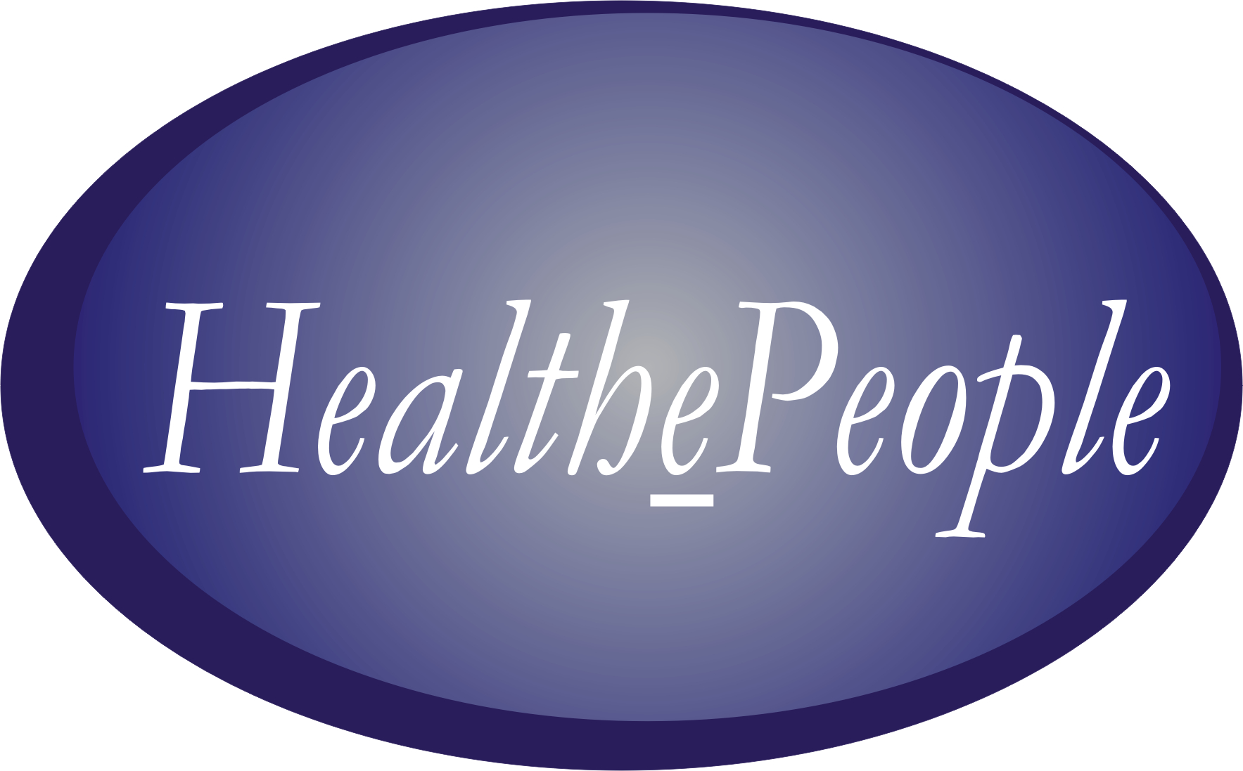
Gary A. Christopherson

CARE IN THE COMMUNITY

In America today, much of what impacts health occurs outside the direct health care system. This includes the impact of self care, personal behavior, and the environment. Further, four forces are changing how we support health for Americans. First, more and more care is being provided in non-hospital settings for a number of reasons. Second, eHealth is developing quickly as a means to extend health support outside of and with health care facilities. Third, personal involvement in and control over health is increasing as people understand a) the impact of personal health behavior and health environment on health status and b) the tools and information available to help improve health status. Fourth, given that sustaining and improving health is increasingly about chronic illnesses and behavioral change, the need for a continuing “partnership” between people and their clinicians is growing. With this developing future, what we are choosing to call “care in the community” offers a model for improving the use of scarce health resources and for improving personal health.
The purpose and desired outcome of this effort is to help improve health status via the enhanced system of care that makes use of effective “care in the community” and “personal health systems/records”, such as the concept of a “My HealthePeople.”

Potential “Care in the Community” Model
What is the model? How might it function to improve health? [See Figure 1. Care in the Community Model] Care in the Community is built on the principle that the person is the center of the “health universe.” All health support should be person-centered and be coordinated to improve their personal health and the health of those in their own “personal community.” It recognizes and addresses that a person’s health status and needs change over time as people move through periods of wellness, acute episodes and chronic illness and disability. A person may be experiencing both acute and chronic illnesses at the same time. A person may be relatively well and, at the same time, have a well-managed chronic illness. A person may have a disability and still be functioning well due to prosthetics use or other care. Care in the community seeks to support the whole person and their own “personal network” and the full scope of needs over time. Care in the community builds upon clinic and hospital resources, enhances them with care outside those care settings, helps bring all health resources together and coordinates care in a person-centered way and with an effective partnership between the person and their clinician(s).
In terms of a model for such a “care in the community” system, Figure 2 depicts one model for building a system that is person centered incorporating a) direct interactions with one or more health care providers and b) utilization of a personal health system (e.g., like the concept of a My HealthePeople) for self care and shared care management with one or more health care providers.

Figure 1. Model of “Care in the Community” with a “My HealthePeople” type PHS

Figure 2. Person Centered View of “Care in the Community” With Supportive Services and Interactions, including the concept of “My HealthePeople” type PHS

Potential “Care in the Community” Supportive Services
This model can help improve self and shared care and brings to bear, via a My HealthePeople type personal health system, a wide range of supportive services, including health record access, self-entered health information, messaging between clinician and person, trusted eHealth information, automated eHealth program transactions, and eHealth program support (electronic health services targeted at managing and improving health). A personal health system could potentially support the person and coordinate care in the following ways:
- Health Record
  - Access part of or whole electronic health record
  - Self-enter personal health information
  - Share person’s electronic health record among health providers
  - Share persons’ electronic health record w/ family or “delegate”
- Messaging (with health provider)
  - [See Health Support” services for additional “messaging” opportunities]
- eHealth Program Information
  - Receive trusted information via access to website
  - Receive trusted information via health provider programs and facilities
  - Access links to health-related sites
- Automated eHealth transactions
  - Check and/or fill prescriptions
  - Check, confirm and /or make appointments
  - Check co-payments; make co-payments
  - Register for benefits and/or care; communicate change in registration status
- eHealth Program Support
  - Coordination of care
  - Self-assess health (e.g. self-monitoring; identify health problems)
  - Access basic “diagnostic/therapeutic” tools appropriate for self-management
  - Monitor health (e.g. report blood pressure, glucose, pain, weight, wounds)
  - Participate in sponsored support or discussion groups
  - Receive health behavior reinforcement (e.g. reduce smoking and alcohol use)
  - Have telehealth consult with health provider
  - Access safety services (e.g. drug-drug interaction checks)
  - Receive electronic reminders (e.g. taking pills on time; upcoming appointments)
  - Use “check in”, for those living alone and at risk, to report they are “okay”
  - Bi-directional question/answer between providers and persons
  - Receive notification of non-sensitive test results
  - Track progress on treatment

Potential “Care in the Community” Impact on Health and Health Care
In envisioning the results of this effort, the “care in the community” strategy substantially changes how we support health. Under this strategy, we move to a person and population centered health system. We create a partnership between people and their health providers. We enhance self and shared care already being done. We strengthen and expand care provided in the community. We tightly coordinate and integrate care in health care facilities with care outside health care facilities. And, we use eHealth personal health systems (e.g., like the concept of a My HealthePeople) that includes records, messaging, transactions, information, and services to support and tie together the full range of care.

Care in the community lends support to optimizing health, abilities and satisfaction of the people targeted by the strategy. It moves from a reactive “safety net” mode into a proactive “intervene early” and “keeping people healthy” mode. It supports targeted interventions to specific populations (an “enrolled” population, people who are relatively well, people with acute episodes, people with chronic illnesses and people with severe chronic illness and/or disability). Through mass personalization of eHealth, it supports targeted interventions to specific individuals based on their individual needs and preferences. For organizations that see themselves as taking responsibility for the health of their population (a “public health” perspective), “care in the community” helps. For organizations that are trying to get more benefit for the same dollars, it can help stretch those dollars further. For those trying to use all the available care settings to their best advantage, care in the community adds settings. Care in the community also can help health care organizations better use best practices and more ideal systems. It also brings to bear a more optimal use of health and information technologies to improve people’s health.

Progress to Date
The origins of “care in the community” go back thousands of years to when “health care” began and before there were hospitals and clinics. It goes back to the origins of “public health” and its changes over the years. It builds upon the history of long term care that started as a home/community approach, moved to more of a nursing home approach and has been moving back to a greater emphasis on community approaches. Today, we want to support people’s ability to function well and sustain and improve their health and we wish to focus more on a) what does and should happen in the community and b) how best to coordinate and integrate health support in health facilities and in the community.
Building on this recognition that care in the community is essential, technology is now providing a wide array of enabling, electronic tools. Especially in the past several years, health technology is enabling monitoring tools, access to provider-based and self-entered health records, messaging between people and their clinicians, access to information, transactions between people and their health providers and the provision of eHealth supportive services (e.g., assessment tools, reminders, reinforcement, group interventions).
At this time, a number of health organizations have personal health systems to a greater or lesser extent. They include the Veterans Health Administration (My HealtheVet), Kaiser-Permanente, Partners Health, and the Military Health System (Department of Defense). Some are primarily used for “trusted” information. Some enable basic transactions (e.g. prescription refills, checking and making appointments). Some provide access to the provider’s electronic health record. Some support self-entered information by a patient. Some are developing eHealth services to move more services out into the “community”. Only a very few health provider organizations are working on a comprehensive personal health system that provides all these capabilities. There are only the very beginnings of work on a comprehensive personal health system (e.g., like the concept of My HealthePeople) that a) is not provider-based, b) is “owned” and controlled by the person, and c) enables the person to “link” with all their providers and with other health resources.

REFERENCES

Information gathered, during the period from 2001 through 2004, from meetings and work with the following organizations: Connecting for Health, Foundation for Accountability, Department of Health and Human Services (several components including CMS, AHRQ, Office of Disease Prevention and Health Promotion), eHealth Initiative, Institute of Medicine, Kaiser-Permanente, Military Health System (Department of Defense), Partners HealthCare, The Robert Wood Johnson Foundation, Veterans Health Administration (Department of Veterans Affairs).
Connecting for Health. 2003. A Public-Private Collaborative: The Personal Health Working Group. Online. Available at http://www.connectingforhealth.org/resources/final_report_phwg_cfh.pdf [accessed February 24, 2004].
Institute of Medicine. 2001. Crossing the Quality Chasm: A New Health System for the 21st Century. Washington, DC: National Academy Press.
Institute of Medicine. 2003. Priority Areas for National Action: Transforming Health Care Quality. Washington, DC: National Academy Press.

“My HealthePeople” is a concept for an electronic personal health system that a) is owned and controlled by the person, b) serves as a web portal, and c) enables coordination of care, trusted health information access, electronic health record access and sharing, transactions, messaging among persons and clinicians, and eHealth program health support (e.g., moderated discussions, chronic disease management and monitoring, risk reduction)

