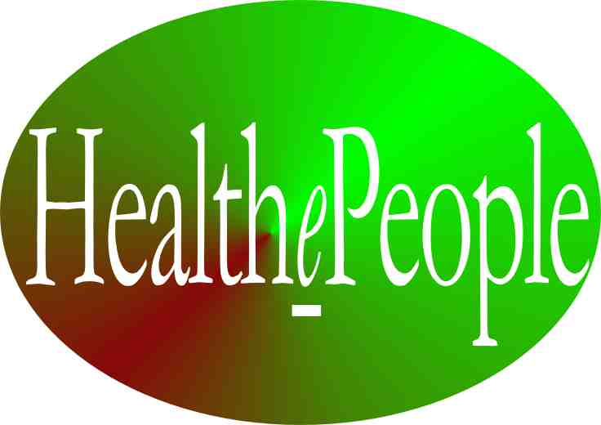
HealthePeople® – Vision and Strategy for Achieving a Healthy and Thriving Future
Rationale
Today in America, we are spending over 1/6th (over $3 trillion) of our national economy on health without producing healthy Americans or a healthy America. Most of the rest of the world faces major challenges in achieving healthy people and healthy nations. The 2010 American Health Reform law is very helpful but is not enough. Without a large change in health vision, strategy and execution, our future will be as disappointing as our past.
Vision and Strategy
Thrive! is the overall vision, mission and strategy. HealthePeople is the vision, mission and strategy for health and well-being. HealthePeople is a strategy whose near-term vision is to achieve substantially healthier Americans and a substantially healthier America and to achieve substantially healthier people and substantially healthier nations. The long-term vision is to achieve healthy, thriving people globally and a healthy, thriving world. This HealthePeople strategy was created with the belief that we can reach this vision via an endgame strategy of high performance, health systems for all people that is self-perpetuating, affordable, accessible, “e” enabled, person-centered, prevention-oriented, and producing high health quality, outcomes and status. Such systems, partly physical and partly virtual and put into place by collaborative private and public partnerships, will greatly improve accessibility, quality, affordability and health status for all people. Such systems can help achieve a healthy, thriving world.
Guidance
This strategy is guided by and aligned with the Institute of Medicine (IOM) recommendations. What people want from a high performing health and long term care system is “staying healthy”, “getting better”, “living with illness or disability” or “coping with the end of life.” IOM has six aims for a high performing health system - safe, effective, person/patient-centered, timely, efficient, and equitable.
Supportive Strategies
Using HealthePeople strategies and models, we can positively transform health systems and achieve a healthier America and world by successfully applying the following 15 strategies:
- Create a supportive environment for high performance, quality, affordability, accessibility
- Support strong person-centered health with high personal choice, self care and a strong partnership between the person and their health professional/provider to improve resource use and health outcomes
- Support strongly and collaboratively applying “public health” model
- Support all needed care reasonably accessible financially
- Support the most vulnerable persons being provided all needed health and long term care (LTC) support
- Support strong core health benefits
- Support strong core long term care benefits
- Support strong person-centered care coordination/management
- Support effectively using prevention to avoid illness and disability and associated cost
- Help ensure long term affordability
- Support pay for effective care & effective resource use
- Support aligned high performance measures for all/across care settings
- Support strong quality/performance improvement for all/across care settings
- Support all care settings being reasonably accessible physically
- Support strong virtual health information system with EHRs, PHS/Rs, standards & interoperability/exchange
Within these strategies are two core elements:
- First, achieve affordable, accessible, and high quality/performance health systems.
- Second, focus on people, in partnership with their clinicians, as the center of the health universe.
Building a Healthy and Thriving Future

We should proceed under the belief that we can reach this vision via the above endgame strategy. Utilizing HealthePeople as an organizing strategy, we can build a substantially healthier world and move toward a truly healthy and thriving future. People deserve and should expect nothing less.

HealthePeople® –
Vision and Strategy for Achieving a Healthy and Thriving Future

Executive Summary
Today in America, we are spending over 1/6th (over $3 trillion) of our national economy on health without producing healthy Americans or a healthy America. Most of the rest of the world faces major challenges in achieving healthy people and healthy nations. The 2010 American Health Reform law is very helpful but is not enough. Without a large change in health vision, strategy and execution, our future will be as disappointing as our past. To positively change that future, HealthePeople is a strategy whose near-term vision is to achieve substantially healthier Americans and a substantially healthier America and to achieve substantially healthier people and substantially healthier nations. The long-term vision is to achieve healthy, thriving people globally and a healthy, thriving world. This HealthePeople strategy was created with the belief that we can reach this vision via an endgame strategy of high performance, health systems for all people that is self-perpetuating, affordable, accessible, “e” enabled, person-centered, prevention-oriented, and producing high health quality, outcomes and status. Such systems, partly physical and partly virtual and put into place by collaborative private and public partnerships, will greatly improve accessibility, quality, affordability and health status for all people. Such systems can help achieve a healthy, thriving world.
Rationale
There is and should be little disagreement over the need for America and the world to have substantially better health systems. In America, none of the key indicators – health status, accessibility, quality, affordability – are at acceptable levels for a nation spending over 1/6th of its economy on health. Other nations have their own set if issues that fail to produce a sufficient level of health.
- Accessibility – Even with the 2010 health reform, millions of Americans are uninsured for health care and millions more are underinsured. Most Americans are uninsured or underinsured for long term care. Needed health (including long term care) services are insufficiently available and/or accessible to many inner city and rural communities. Here in America and globally, a collaborative partnership of people, public and private payers, and health care organizations can substantially improve access for all people.
- Quality – Health status and outcomes produced by current health systems are inadequate given the needs of people in America or globally and given that America expends over 1/6th of the national economy on health care. The 2010 health reform in America makes some but far too little progress. In America and globally, too little of our medical and health knowledge is being effectively applied to prevent and treat health problems, to ensure health care is safe and to achieve high health status. A collaborative partnership of health care organizations and the people they serve can substantially improve health care quality, health outcomes and health status for all people.
- Affordability – The unaffordability of health care is particularly challenging in America (expending over 1/6th of the national economy and growing) and Americans as individuals and families (inhibiting needed access and causing bankruptcies). Similar issues of affordability face other nations as well. The 2010 American health reform makes some progress on affordability by improving insurance access but makes relatively little progress on improving affordability overall. Without further action, these problems will continue to grow. The same is true for other nations. A collaborative partnership (health care organizations, the people they serve, and the people and organizations who pay) can much more effectively use valuable health resources. America is spending enough money. Other nations vary widely on the relationship between spending and need. Globally, we are just not getting the requisite payoff in terms of health outcomes/status or satisfaction.

Guidance
HealthePeople is a strategy guided by and aligned with the Institute of Medicine (IOM) recommendations. IOM provides a way of viewing the health system’s performance through the eyes of people themselves. What people want from a high performing health and long term care system is that they are “staying healthy”, “getting better”, “living with illness or disability” or “coping with the end of life.” Some people may experience more than one of these at the same time. IOM’s quality reports have six aims for a high performing health system. They stress it should be safe, effective, person/patient-centered, timely, efficient, and equitable.
Utilizing their guidance, a very high performing health and long term care system would perform well from the person’s perspective and achieve the IOM aims. As depicted in the attached table, that very highly performing health system would “check all the boxes.” (See “Institute of Medicine Six Aims & Person’s Perspective on Health”)

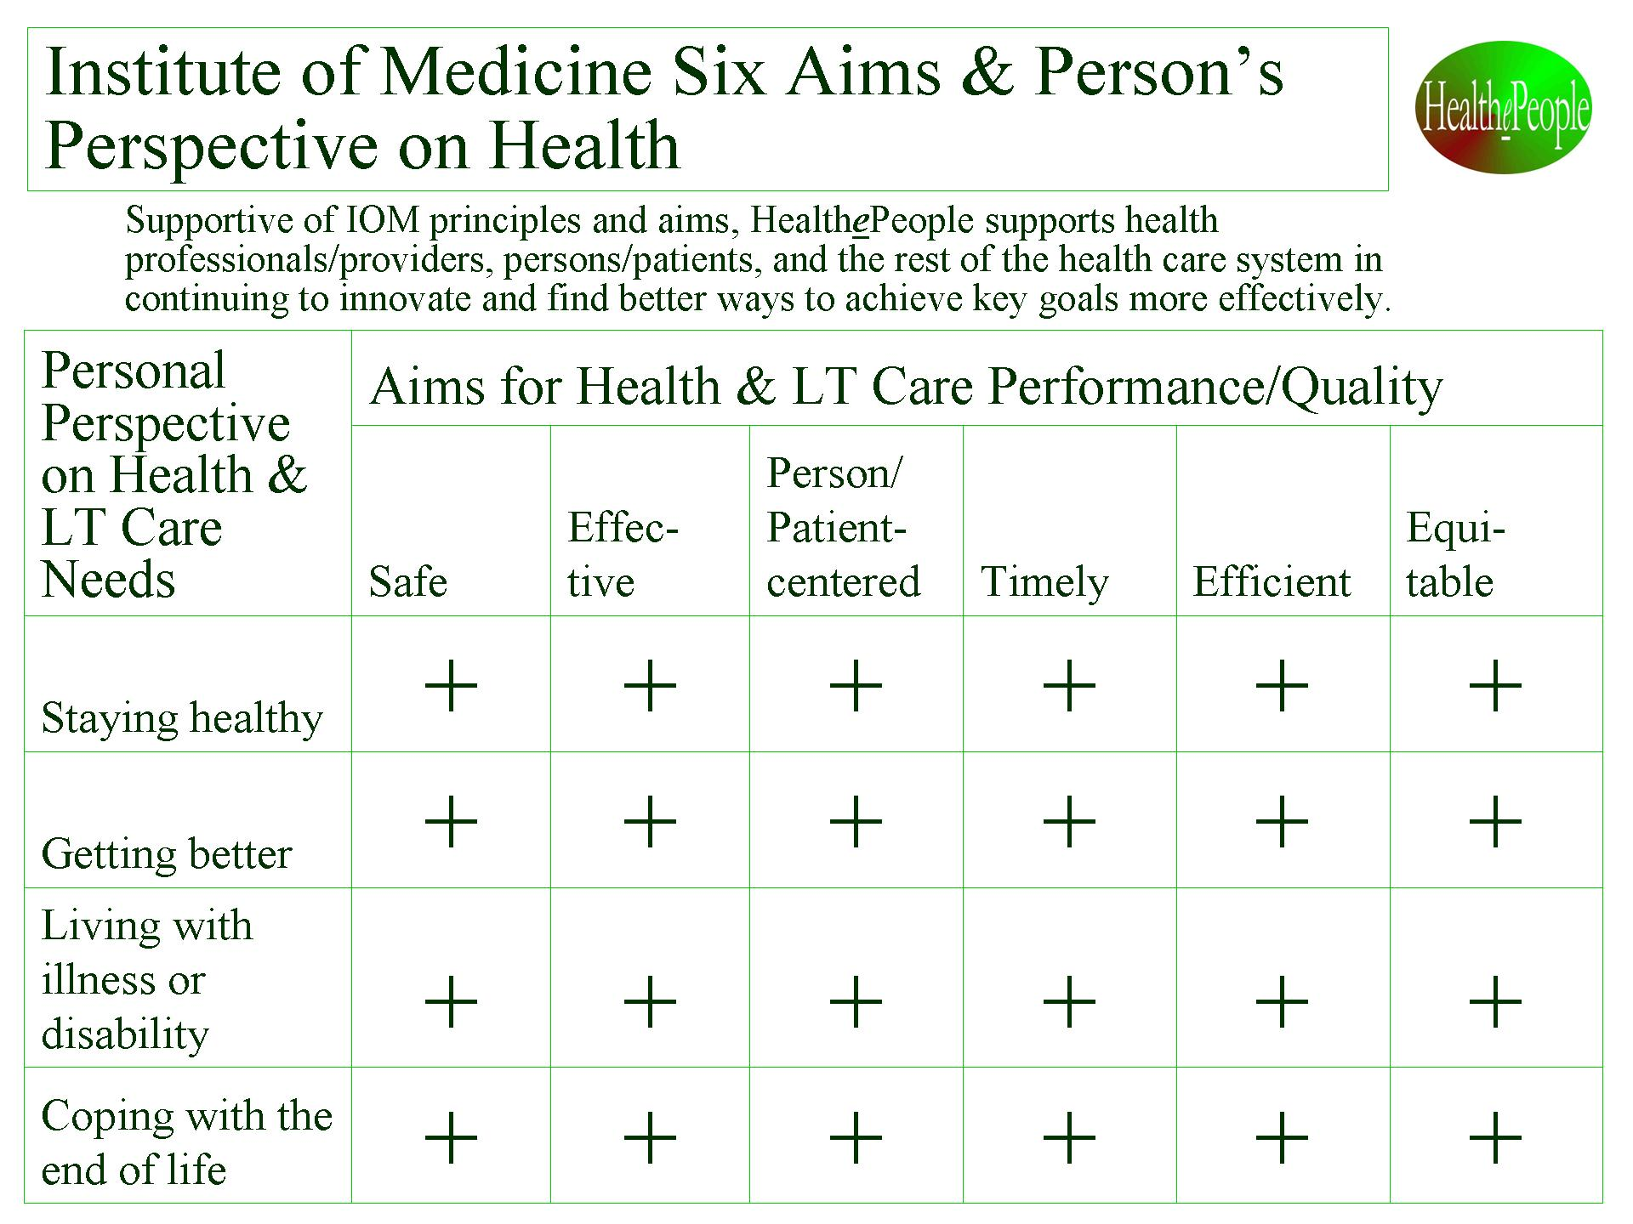

Figure 1. “Institute of Medicine Six Aims & Person’s Perspective on Health”

Second, we need to recognize the following as key health drivers and use them to guide our work and measure our progress toward a healthy America and world:
- Maximize health status
- Maximize outcomes
- Maximize abilities
- Maximize satisfaction
- Maximize quality
- Maximize accessibility/ portability
- Maximize affordability
- Maximize patient safety (drive defects/errors to zero)
- Minimize time between disability/illness and maximized function/health (drive time to zero)
- Minimize inconvenience (drive inconvenience to zero)
- Maximize security & privacy

Third, we need to understand and successfully deal with the American and other nations health systems’ complexity if we want to substantially improve health outcomes and health status for all people. The Figure below lays out the complexity gauntlet which must be successfully run for America. (See “Strategy for Complex American Health” System”) To be fully successful in America and the rest of the world, we have to address the people factors (population, diversity, insurance status, health factors, health-related factors) and the non-people factors (health resources, health care, health-related environmental factors). We should focus on a) affecting the actions that improve/reduce health quality to b) create a strong partnership between the person and their clinicians to c) improve health care quality and effective resource use those results to d) substantially improve health outcomes and status.

Vision, Endgame Strategy and Mission
Thrive! is the overall vision, mission and strategy. HealthePeople is the vision, mission and strategy for health and well-being.
The HealthePeople near-term vision – achieve substantially healthier people and a substantially healthier America and world - is far different than the one we can expect from our current glidepath. Much more so is the long-term vision - achieve healthy and thriving people and a healthy and thriving America and world. All current indicators and trends point to a future where access, quality and affordability continue to be unacceptable. Under a better vision and strategy with the same resource commitment, we can achieve substantially healthier people and a substantially healthier America and world.
To reach this vision, the endgame strategy is to achieve high performance, health systems for all people that is self-perpetuating, affordable, accessible, “e” enabled, person-centered, prevention-oriented, and producing high health quality, outcomes and status. Effective health systems should bring together and to bear the full force of people and their clinicians, their healthcare providers, their healthcare payers, their communities and their governments.
To reach this vision and endgame strategy, the mission is to create and support collaborative partnerships that help build high performance, health systems for all people that are self-perpetuating, affordable, accessible, “e” enabled, person-centered, prevention-oriented, and producing high health quality, outcomes and status. This unprecedented collaboration can achieve great progress as we have seen America and other nations achieve historically on other national issues. HealthePeople achieves full success when health systems achieve and sustain healthy and thriving people and a healthy and thriving America and world.

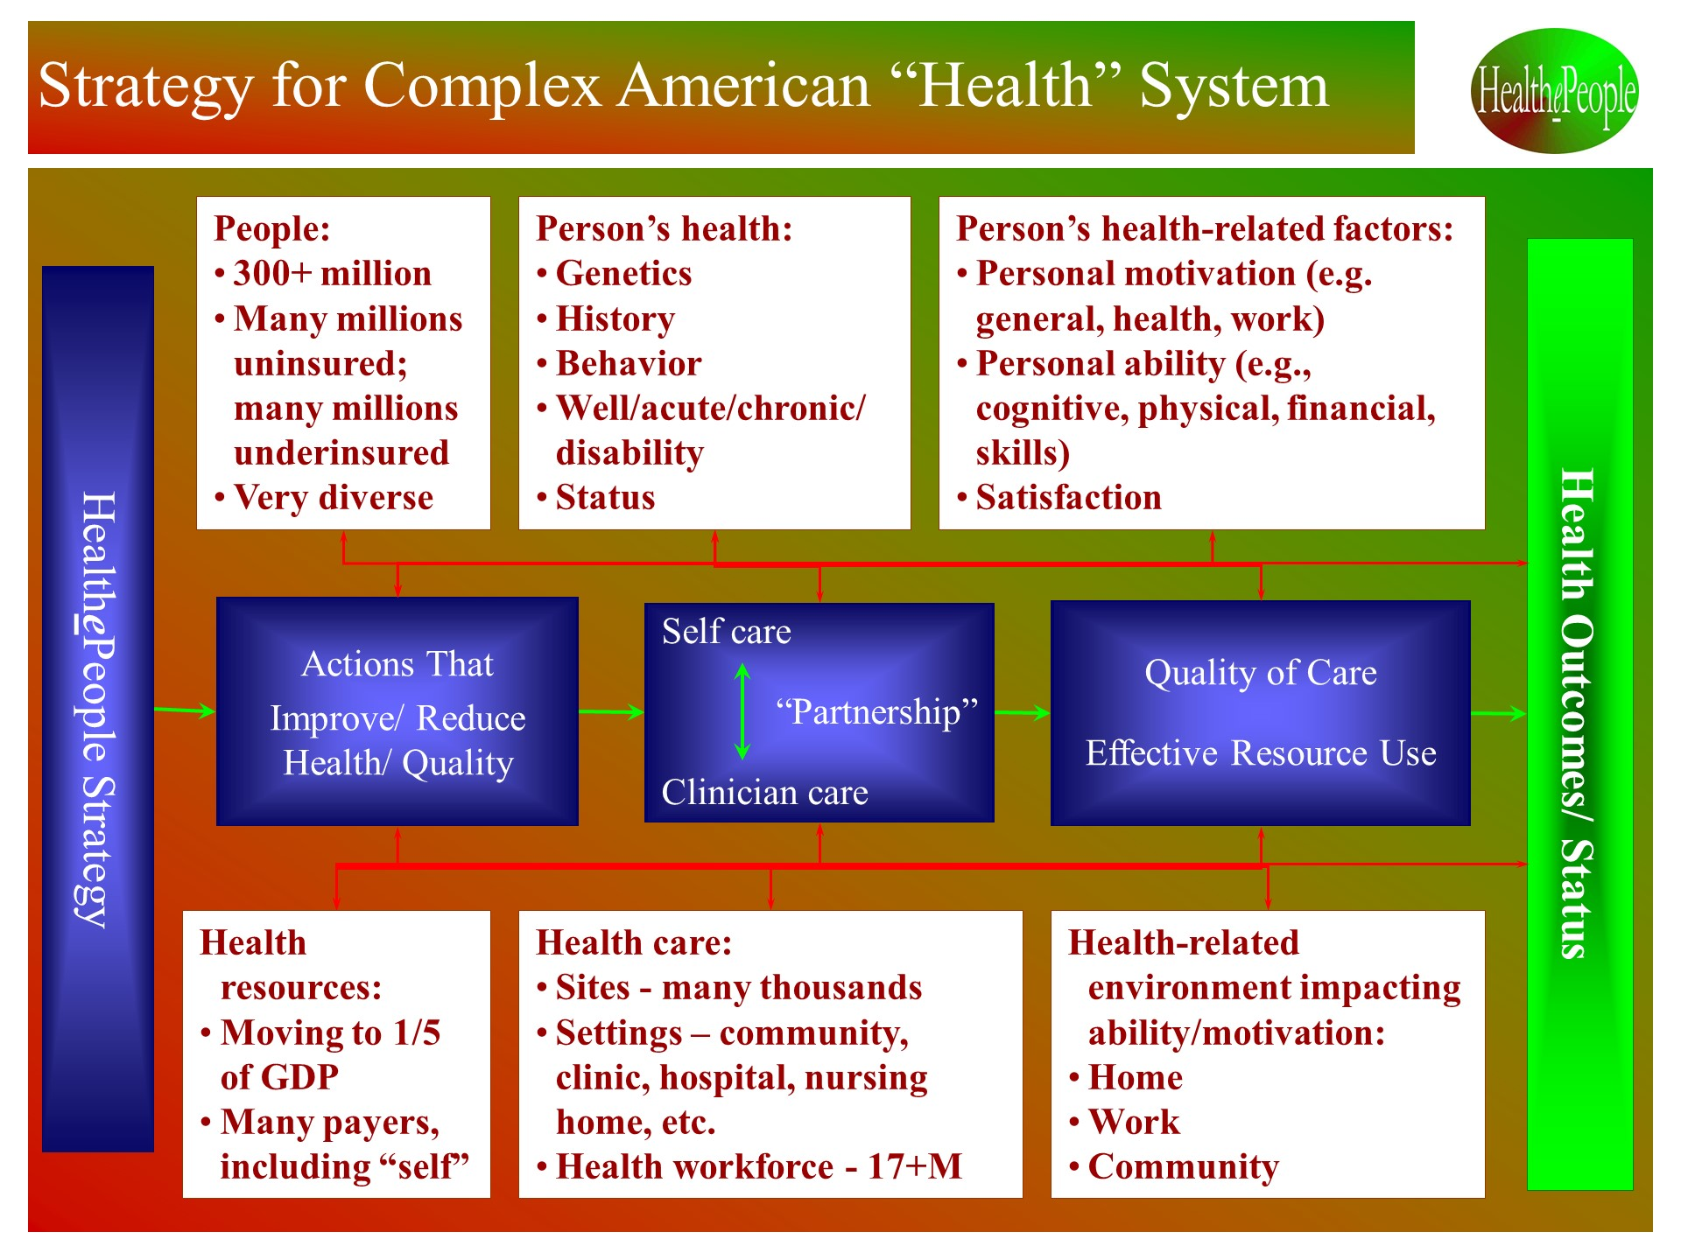
Figure 2. “Strategy for Complex American Health” System”

Strategy for a Healthy and Thriving Future
HealthePeople is a collaborative strategy to transform to affordable, person-centered, prevention-oriented, outcomes-driven, and "e" enabled health systems that help achieve better health. Succeeding with this strategy across all of health will positively transform health care. We can use our nation’s and world’s valuable health resources much more effectively, reduce vulnerability, and achieve much healthier people and a much healthier America and world. Within this strategy are two core elements:
- First, achieve affordable, accessible, and high quality/performance health systems. This involves more than medical interventions or traditional healthcare services. It requires a full range of health-related resources from across the community and beyond.
- Second, focus on people—consumers, patients, enrollees, and members. They are the center of the health universe and must be treated as such, forming strong partnerships between individual persons/patients and their healthcare providers.
To build out the strategy and supportive strategies, this strategy utilizes a public health intervention model designed to help increase the number of healthy people and reduce the number of vulnerable and/or unhealthy people. (See “A Healthy/Thriving Future - Vision and Strategy”) This model applies to Americans and people worldwide. It targets interventions that best achieve the highest level of health and function, best prevent more poor health, and best move our most vulnerable people up from poor health. The success of the interventions is measured by the degree to which we stop actions that decrease health and support actions that improve health. Success is also measured by how well the private and public sectors, including health professional leadership, “move the numbers”, i.e., substantially improving the key status indicators of health and function.
Within the model, there are interventions that improve health or make it worse. To improve health, there are the overall key strategic areas – stop those interventions/actions that make health worse support those interventions/actions that improve health. To improve health most, we need to execute a "systematic strategy" – a “system” of actions that continuously stops actions that push people down to less healthy states and supports actions that lift people out of poor health and toward being healthy. This “system” of actions, when well designed and executed, can perpetually prevent much poor health and support people moving up from poor health to being healthy.

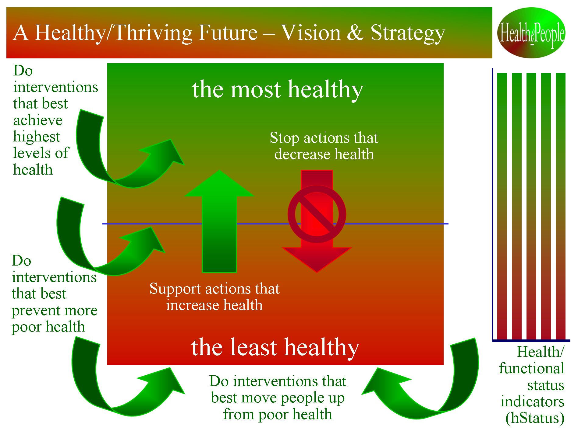
Figure 3. See “A Healthy/Thriving Future - Vision and Strategy”

The overall strategy is built upon a strategic improvement and behavior model for health. Using the model depicted below, we need to set the target health and functional status we are trying to achieve under the vision Healthier/healthy Americans and healthier/healthy people globally”. (See “Building High Performance, Virtual Health System – Strategic Improvement and Behavior Model”) This model applies as well to health systems throughout the world. Given the target status, we can decide on the target outcomes needed and on the target health system needed to achieve those outcomes. Comparing the optimized outcomes and health system with the current health system and its performance, we can determine the “delta”, i.e., the needed improvements in the current health system and its outcomes.
Knowing what needs to be improved, we can then determine what personal and health provider behaviors should change. Human behavior, both by persons (beneficiaries, enrollees, consumers, patients) and health providers, is key to making and sustaining the improvements. The behavioral model helps us think through how we bring about the behavior change necessary to make the improvements. Together, the system and behavior changes are intended to produce improved health and functional status for all Americans and all people globally.

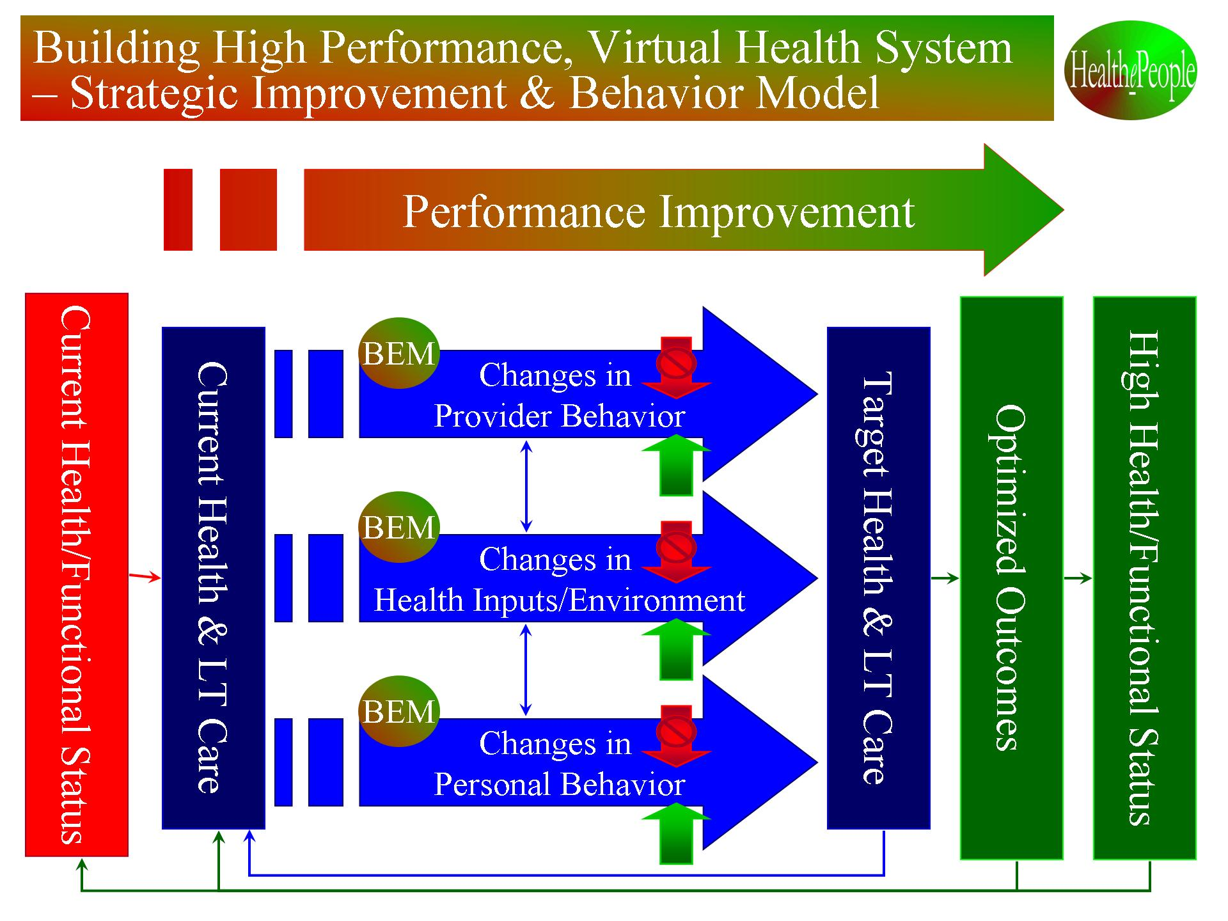
Figure 4. “Building High Performance, Virtual Health System – Strategic Improvement and Behavior Model”

Under the HealthePeople vision, overall strategy and models, we can positively transform health systems and achieve a healthier America and world by successfully applying the following 15 supportive strategies:
- Create a supportive environment for high performance, quality, affordability, accessibility
- Support strong person-centered health with high personal choice, self care and a strong partnership between the person and their health professional/provider to improve resource use and health outcomes
- Support strongly and collaboratively applying “public health” model
- Support all needed care reasonably accessible financially
- Support the most vulnerable persons being provided all needed health and long term care (LTC) support
- Support strong core health benefits
- Support strong core long term care benefits
- Support strong person-centered care coordination/management
- Support effectively using prevention to avoid illness and disability and associated cost
- Help ensure long term affordability
- Support pay for effective care & effective resource use
- Support aligned high performance measures for all/across care settings
- Support strong quality/performance improvement for all/across care settings
- Support all care settings being reasonably accessible physically
- Support strong virtual health information system with EHRs, PHS/Rs, standards & interoperability/exchange

The following Figure lays out from right to left how a) high health and functional status is produced by b) optimizing health outcomes which are produced by c) an affordable, accessible, “e” enabled and high quality health system which is produced and enhanced by d) a supportive health environment and high person-centered and health care performance which is produced by e) the successful application of 15 strategies. (See “Strategies for Achieving a Healthy and Thriving Future”)

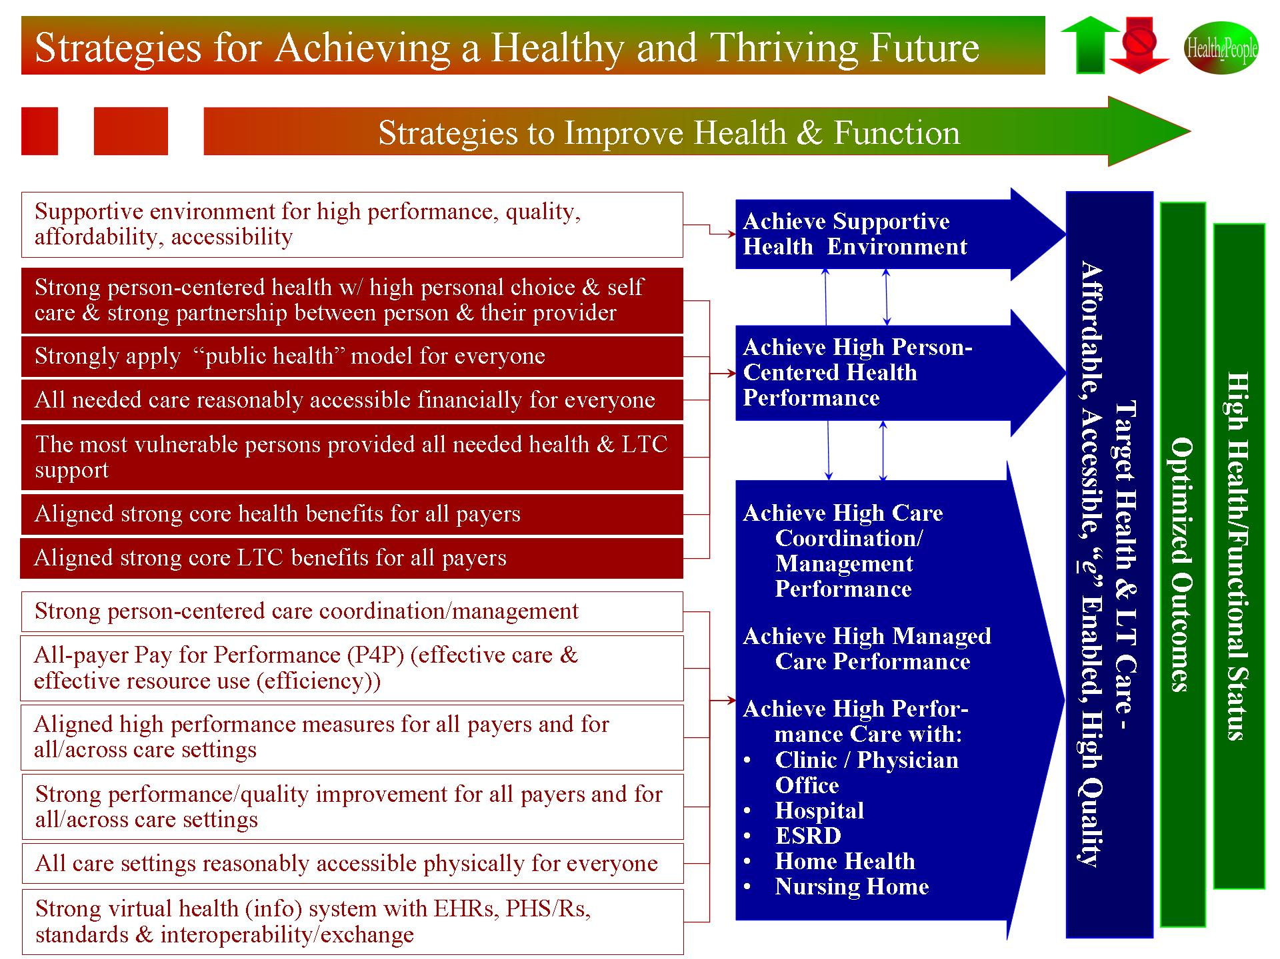

Figure 5. Strategies for Achieving a Healthy and Thriving Future”

While all 15 supportive strategies are essential, there are several strategies that have unique potential and deserve elaboration and greater attention:
- Person-Centered Health - where the person a) is at the center of self care, formal health care and informal health support and b) has that health care/support coordinated via an effective person and clinician partnership.
- High Performance Health Systems - where the best systems design and operational thinking is applied to and across the full range of health care settings from individual clinics to hospitals to integrated health systems to public health to non-traditional health support.
- Care in the Community – where care coordination and eHealth are utilized as means to better support people’s health outside (“in the community”) and with health care facilities in real time at any time and anywhere.
- Quality/Health Improvement - where we build upon IOM work on quality, better use evidence-based care, and develop and use behavioral models for person and clinician behavior to improve health care quality and health outcomes and status. One key focus is “right care for every person every time.” Another key focus to more effectively use prevention and early intervention to avoid illness and disability.
- Un- and Underinsured - where we build upon IOM work on uninsured and develop and execute strategies that solve the un- and under-insured problem in way supportable by key leaders and American public.
- Virtual Health Systems - where we develop and use “virtual health system(s)” of electronic health records (EHR), personal health systems/records (PHS/R), information exchange (IE) and standards. Though “virtual health systems” are only part of the answer, creating an American health system requires the enabling “e”.

HealthePeople Vision and Strategy for a Healthy and Thriving Future

As a nation and world, we should proceed under the belief that we can reach this vision via an endgame strategy of high performance, health systems for all people that is self-perpetuating, affordable, accessible, “e” enabled, person-centered, prevention-oriented, and producing high health quality, outcomes and status. Such health systems, partly physical and partly virtual and put into place by collaborative private and public partnerships, will greatly improve accessibility, quality and affordability for all Americans and all people worldwide. Utilizing HealthePeople as an organizing strategy, we can build a substantially healthier America and world and move toward a truly healthy and thriving America and world. Americans and people across the world deserve and should expect nothing less.

