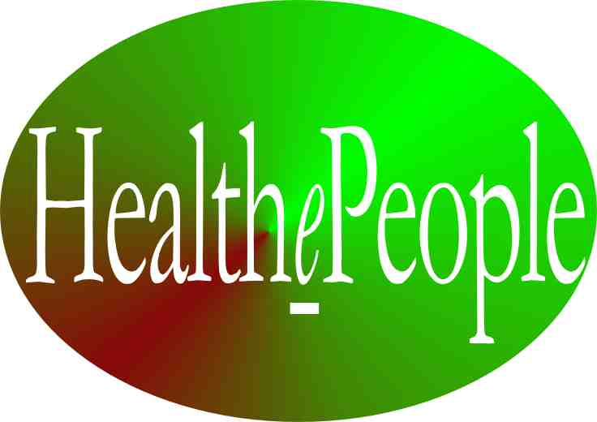
Gary A. Christopherson

PERSON-CENTERED HEALTH

“Person-centered health”, in its entirety, is really different than almost any care provided today by any health provider or health system. But if “health” is really what we want to achieve, then we suggest that “person-centered health” is how we need to operate.

It is different in attitude, culture, design and operation. It is different in using the term “person” rather than terms like patient, consumer, or enrollee. It is different in that it views the person and her/his “self care” as necessary to the successful achievement of health. It is different in using the term “health” rather than the term medicine. It is different in its focus on “health” rather than illness and disability. It is different in its focus on health status rather than illness or disease burden. It is different in focusing on “health outcomes” rather than treatment outcomes. It is different in using the term “electronic health record” versus electronic medical record. A “health” system integrates care inside and outside of medical/health care facilities while a medical care system focuses more on the care provided within medical/health care facilities. It is not just about “care” but is about all of the factors in a person being healthy or not. The focus is on what is trying to be accomplished rather than on what is being done or what is being corrected or prevented. All of these other terms have value but should not be the primary drivers or define the end goal or how we get to that end goal. Health is the end goal.

Health Care – When Is It Not Person-Centered and When Is It?

While many providing health care today believe they are providing “person-centered health,” many of them and many others, in the true sense of the term, are not. What are indications that health care is not truly person-centered?

- Not putting the person at the center of health care plan development and delivery.
- Not an optimized involvement of the person in self care.
- Not a partnership between the person and his/her clinician.
- Not making a person’s satisfaction with care a critical success factor.
- Not addressing the critical role that a person’s behavior plays (especially for chronic care and prevention) nor how to achieve target behaviors (e.g. medication adherence, smoking cessation, weight reduction, post-surgery follow-up).
- Not optimizing health outcomes and status for the person.
- Not providing care between episodes of illness.
- Not providing care in a way in which the person is better willing and able to succeed.
- Not sharing the right information at the right time in a way usable by the person.
- Not having an electronic health record (EHR) covering all of a person’s care by that provider and by other health providers.
- Not having an electronic personal health system (PHS/R) that a person can use to get information, make transactions, self-enter information, access the health record, message with clinicians, access eHealth support services (e.g. risk reduction programs, moderated group sessions) or help coordinate care.
- Not sharing/exchanging (when appropriate and authorized) a person’s electronic health record information with another health provider involved in the person’s care.
- Not checking for and avoiding conflicting therapies (e.g. drug-drug interaction).
- Not doing prevention or early intervention well.
- Not truly personalizing (not doing “mass personalization”) population-based health programs.
- Not addressing co-morbidity (e.g. multiple illnesses requiring multiple medications) well.
- Not taking a good personal and family history nor fully incorporating it into the care plan.
- Not taking into account the family, friends, coworkers and other parts of a person’s community that impact health or involving them when appropriate.
- Not coordinating across all settings (self care, clinic, hospital, nursing home, community care).
- Not coordinating across all providers (primary care, specialty and subspecialty care).
- Not taking into account the person’s environment (home, work, community)
- Not preparing for the potential role genetics will play in prevention and health care.
- Not operating at the convenience of the person but instead primarily operating at the convenience of the health provider.
- Not paying sufficient attention to persons without financial access and putting all the care and attention on those with financial access.
- Not worrying about the affordability of care to the person or her/his payer(s).
- Not helping with the “portability” of care and the information necessary to make care portable.
- Not taking the extra steps to ensure the provided health care is safe.
- Not appreciating a person’s privacy concerns.

What is person-centered health? We would suggest that person-centered health is “The person a) is supported as a unique and whole person who changes over time, b) is at the center of self care, formal health care and informal health support, b) has, receives and provides necessary health-related information, c) has health care/support coordinated via an effective person and clinician partnership, and d) achieves good health outcomes and high health status.

To be truly person-centered, all of the above indicators need to be turned around into a “positive” direction (e.g. the person is put at the center of the development and delivery of a person’s health care plan) as follows:

- Puts the person at the center of health care plan development and delivery.
- Optimizes involvement of the person in self care.
- Has a partnership between the person and her/his clinician.
- Make a person’s satisfaction with care a critical success factor.
- Addresses critical role that a person’s behavior plays (especially for chronic care and prevention) and how to achieve target behaviors (e.g. medication adherence, smoking cessation, weight reduction, post-surgery follow-up).
- Optimizes health outcomes and status for the person.
- Provides care between episodes of illness.
- Provides care in a way in which the person is better willing and able to succeed.
- Shares the right information at the right time in a way usable by the person.
- Has and uses an electronic health record (EHR) covering all of a person’s care by that provider and by other health providers.
- Has (makes available) and uses an electronic personal health system (PHS/R) that a person can use to get information, make transactions, self-enter information, access the health record, message with clinicians, access eHealth support services (e.g. risk reduction programs, moderated group sessions) or help coordinate care.
- Shares/exchanges (when appropriate and authorized) a person’s electronic health record information with another health provider involved in the person’s care.
- Checks for and avoids conflicting therapies (e.g. drug-drug and drug-allergy interaction).
- Does prevention or early intervention well.
- Truly personalizes (does “mass personalization”) population-based health programs.
- Addresses co-morbidity (e.g. multiple illnesses requiring multiple medications) well.
- Takes a good personal and family history and fully incorporates it into the care plan.
- Takes into account the family, friends, coworkers and other parts of a person’s community that impact health and involves them when appropriate.
- Coordinates across all settings (self care, clinic, hospital, nursing home, community care).
- Coordinates across all providers (primary care, specialty and subspecialty care).
- Takes into account the person’s environment (home, work, community)
- Prepares for the potential role genetics will play in prevention and health care.
- Operates at the convenience of the person instead of primarily operating at the convenience of the health provider.
- Provides attention and “care” to persons with and without financial access.
- Makes care affordable to the person and his/her payer(s).
- Helps with the “portability” of care and the information necessary to make care portable.
- Takes the extra steps to ensure the provided health care is safe.
- Appreciates a person’s privacy concerns and protecting privacy, including the security of health records and messages.

Model for Person-Centered Health System.

What is the design for a person-centered health system (e.g. one that included care in the community) and how does it function? How does it ensure that it has the characteristics described above? A model for a person-centered health system is depicted in Figure 1 below.

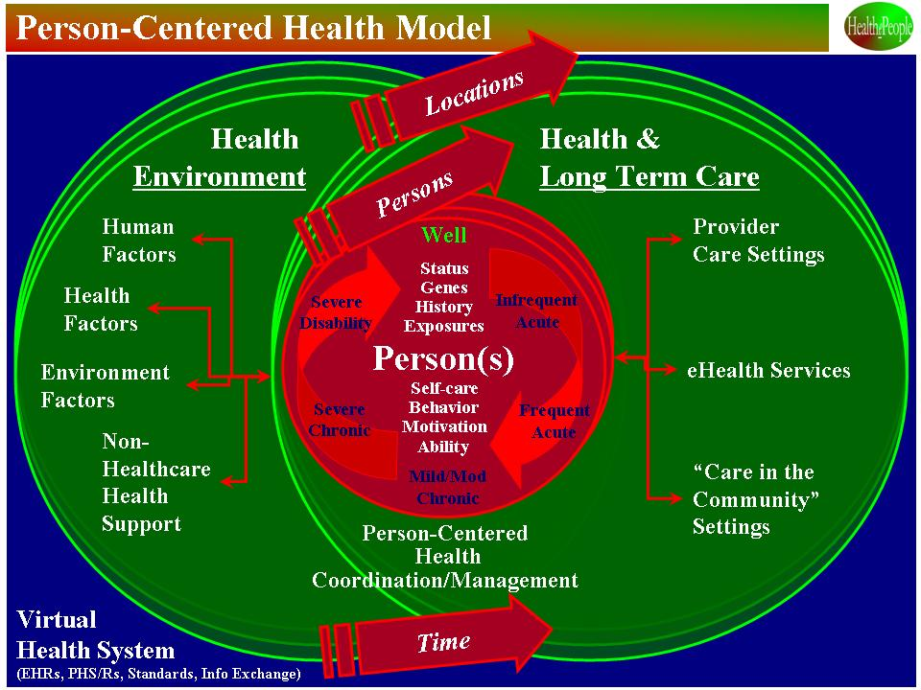

Figure 1. Model for a Person-Centered Health System.

Person At The Center. The person-centered health system starts with the person at the center. Key information on the person is collected, accessed and incorporated into the person’s health plan (what will be done by the person and their clinician together to optimize health outcomes and maximize health status). The system and its clinicians know the person’s current health status, person’s and the family’s health-related history, genetic information and relevant exposures (home, workplace, community). Also, the person’s health related behavior, motivation and ability is known and incorporated. The person’s ability and willingness to do appropriate self care and partner with her/his clinician is built into the person’s health plan.

The health system recognizes how history, current status and potential future health status will play a role in the person’s health plan. It recognizes that at any time, the person may be in one or more states (well, infrequent or frequent acute episodes, mild or moderate chronic illness, severe chronic illness, have a temporary or permanent disability). For example, the person might be well but have a disability with which they have learned to cope well. The person might have a severe chronic illness and be hit with frequent acute illnesses as well. The mix of these states is likely to change over time.

Health Care. With respect to formal health care, the health system accesses the full range of facility-provided care, including clinics, hospitals and nursing homes. But what is the “character” of that care? Formal health care, in a person centered system, creates a partnership between the person and her/his clinician(s), using the best of both and creating a synergy by bringing them together. It makes quality and safety high priorities to avoid doing harm to the person and to optimize health outcomes and status for the person. It understands “accessibility” from the person’s perspective and successfully tackles the full range of access issues (physical, social) to ensure the person gets what care is needed whenever and wherever needed. It recognizes the importance of affordability and takes the necessary steps to ensure affordability for the person and for whoever is the person’s payer.

But a person centered health system goes beyond facility-based care and accesses and integrates in the full range of community-based health care, including home care and assisted living environments. It reaches further and accesses workplace, schools and other community settings as is appropriate. Linking to home, school, workplace and other community health capabilities provides a total health system of health support that recognizes that the person spends most of his/her life outside of health care facilities. This linking also brings to bear key people who can provide health support, including formal health providers and community programs. More will be said later about the role for and value of the person’s family, friends, co-workers and neighbors.

Within a particular system, the eHealth system provides and integrates an electronic health record (EHR), a personal health system (PHS/R), electronic health record exchange with other health providers, standardized data, self-entered information from the person, electronic messaging and phone contact between the person and her/his clinician, trusted health information on issues relevant to the person’s health, eHealth transactions (e.g. prescription drug refills, scheduling) and eHealth program support.

The health system provides or accesses eHealth program support that includes the full range of supportive services that a health system can provide using electronic devices, a computer, the Internet and a phone. They include risk reduction programs, pre-work or follow-up to acute care, and chronic disease management. They provide the opportunity for “mass personalization” whereby eHealth programming can be targeted to those who will benefit most and the programming can be individualized to the person’s specific target behaviors, motivation, ability, and community support system, and to changes over time.

Health Environment. Moving outside the health care system and the formal community programs, there are many influential factors and much potential health support outside the traditional health care system. As suggested on the left side of Figure 1, the “health environment” plays a major role in health outcomes and health status and in how the traditional health care system impacts outcomes and status. It plays key roles in a person-centered health system.

As alluded to earlier, it starts with the people who surround the person, the human factors. These are the people with whom the person spends the greatest proportion of her/his time. The family, at many points in the person’s life, impacts health positively and negatively. It can be a source of positive health influences (e.g. positive reinforcement of positive health behaviors) and it can be a source of negative influences (e.g. poor food choices, stress). The same is true for friends, co-workers and neighbors. A person centered health system recognizes the importance of all these people to the person’s health, takes these influences into account, and works to reduce the impact of negative influences and engage the positive influences.

With respect to the family, there are historical influences. Family history - the influences being behavioral, environmental and genetic - plays a major role in the person’s health. These influences are critical to understanding the person’s health, why it is what it is, and how to positively change it. Research continues on the influence of genetic factors and on what interventions can harness the positive factors and reduce the negative factors.

Beyond the family, there are many other environmental factors – home exposures, work exposures and community exposures. Some are historical. Some are current or future. To improve health requires understanding these exposures, their impact on the person’s health, and their potential for positively or negatively impacting health.

Outside self care and outside the formal health care system are non-health-care community resources. These have many forms and differing value. Some resources are not-for-profit and some are for-profit. Some are relatively informal and some are formal. Some do evidence-based interventions; some do not. Some are trustworthy and some are not. Some are tied to specific illnesses or injuries (e.g. cancer, Alzheimer’s); some are non-health related affinity groups (e.g. senior citizens, religious groups, co-workers). Many of these have health impacts, some negative and some positive. A person centered health system trying to improve health takes them into account and helps to minimize the negative impacts and maximize the positive impacts.

These environmental factors (outside the person and outside of the formal health care system) are built into a person centered health system and its efforts to improve health outcomes and status. Failing to address these factors reduces the probability of improving the person’s health.

Dynamic, Interactive System. If all of this was static and independent, it would be challenging enough. But it is not. The system is dynamic because the locations for health interventions change. It is dynamic because the person changes in many, many respects. It is dynamic because the people providing health support change. It is dynamic because time comes into play as events unfold for the person and, her/his “health system” and “health environment”. Beyond being dynamic, it is interactive where influences are interacting with each other to change how they impact the person and her/his health. Understanding that this is the reality gives the person and his/her clinicians a better understanding of why some interventions work better than others and why interventions need to be dynamic and interactive.

Virtual Health System. Wrapping around this health system and the other health and non-health systems is the eHealth capability to make it a “virtual health system”, bringing together all parts of the formal and informal health system. Part the responsibility for the virtual health system lies with each particular health system and part of this responsibility lies with other parties outside the particular health system. A strong virtual health system “connects the dots” and provides a wide range of support to the person, his/her clinicians and community health support both within a particular health system and across health systems. A person-centered, virtual health system “breaks down the walls” and enables the person and his/her clinicians to better bring to bear the full health resources appropriately, affordably, anytime, anyplace and in real time.

HealthePeople Strategy for Moving to Person-Centered Health and It Benefits.

How do we get to “person-centered health” and the desired results – good health outcomes, high satisfaction and high health status? We suggest there are a series of actions that, if successfully carried out, will help bring about a person-centered health system within organizations like the Veterans Health Administration and the Centers for Medicare and Medicaid Services and across the much of the nation. These actions have been described above and are shown in the full-blown HealthePeople strategy depicted in Figure 2. By weaving together these actions into the HealthePeople strategy and delivering on that strategy, we can increase the probability that we will achieve a person-centered health system and the many benefits such a system should provide.

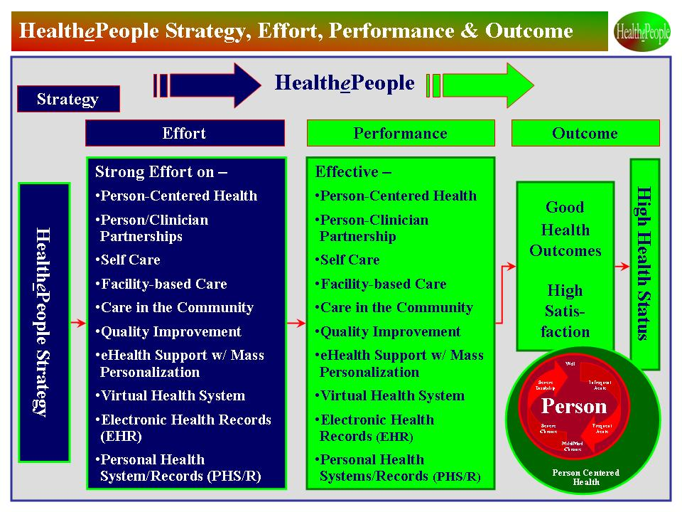

Figure 2. HealthePeople Strategy, Effort, Performance and Outcome.

Conclusion.

Today, four forces are changing how we support health. First, more and more care is being provided in non-hospital settings for a number of reasons. Much of this care focuses more on the person and his/her community. Second, eHealth is developing quickly as a means to extend health support within and outside of health care facilities. Third, personal involvement in and control over health is increasing as people understand a) the impact of personal health behavior and health environment on health status and b) the tools and information available to help improve health status. Fourth, given that sustaining and improving health is increasingly about chronic illnesses and behavioral change, the need for a continuing, effective “partnership” between the person and her/his clinician(s) is growing. With this developing future, what we are choosing to call “person-centered health” offers a model for improving the use of scarce health resources and for improving health outcomes and status.

